**LAB# 5**



**Spring 2023**

**COA Lab**

**Submitted by**: **Abdul Rasheed**

**Registration No**: 21PWCSE2063

**Class Section**: **B**

“On my honor, as student of University of Engineering and Technology, I have neither given nor received unauthorized assistance on this academic work.”

Student Signature: ______________

Submitted to:

**Dr.Bilal Habib**

**Department of Computer Systems Engineering**

**University of Engineering and Technology, Peshawar**

**COA**

**DCSE, UET Peshawar**

**LAB 5 MIPS:**

Q NO 1: Write a program to check whether a number input by user is prime or not.



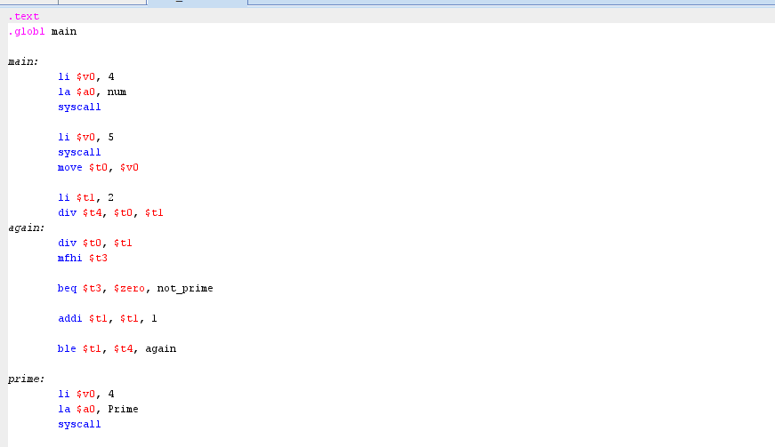

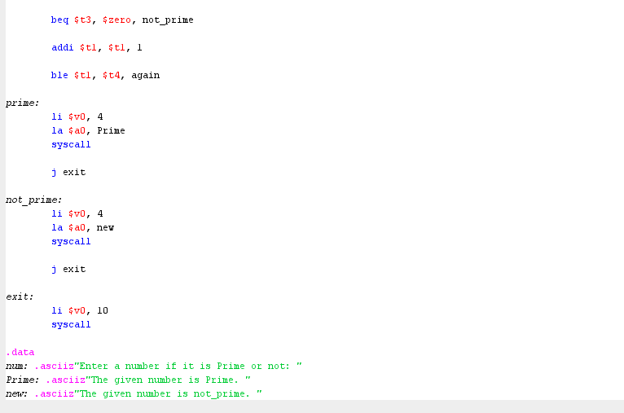

Output:



Q NO 2: Repeat the above problem and display the largest two prime numbers lower than itself. Hint: If a user enters 20, then program displays 19 and 17.

Code:

.text

main:

li $v0, 4

la $a0, msg_input

syscall

li $v0, 5

syscall

sub $t0, $v0, 1

li $t1, 0

loop:

beq $t1, 2, end

move $a0, $t0

jal is_prime

beq $v0, 0, not_prime

li $v0, 4

la $a0, msg_prime

syscall

li $v0, 1

move $a0, $t0

syscall

addi $t1, $t1, 1

not_prime:

sub $t0, $t0, 1

j loop

end:

li $v0, 10

syscall

is_prime:

li $t2, 2

li $v0, 1

check:

bge $t2, $a0, ret

rem $t3, $a0, $t2

beq $t3, 0, fail

add $t2, $t2, 1

j check

fail:

li $v0, 0

ret:

jr $ra

.data

msg_input: .asciiz "Enter a number:\n "

msg_prime: .asciiz "\nPrevious prime:\n "

Output:





Q NO 3: Write a program which takes two limits from user and display prime numbers between the two limits *(if user enter lower limit 10 and upper limit 30 then display prime numbers between 10 and 30).*

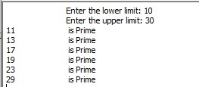

Code;

